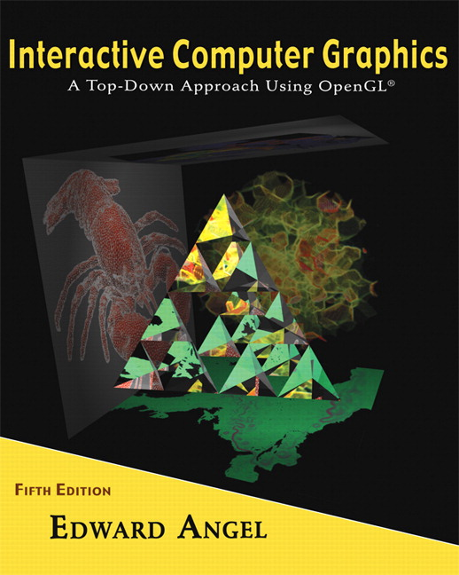

Name: ______________________ Terminal # ____

Programming Assignment 1
(100 points)

The Programming Assignment is to be turned in the first ten minutes of the due date class as:

Hardcopy (with your terminal #!)
Source Code and screenshots that shows that your Visual Studio 2008 “Programming Assignment 1” PROJECT compiles and runs!

Electronic: Submit the Visual Studio2008 “Programming Assignment 1” zipped PROJECT to BB so you can run it in 200 PGH!

HUMANOID - Summer 2011 Modeling Instructions

1. The glutCreateWindow OpenGL call will take as parameter “YourLastName Humanoid Version 1”.
2. The file “Humanoid Summer 2011.pdf” contains the specifications for the humanoid that you will start modeling in this first programming assignment.
3. In the “void myReshape(int w, int h)” function, you need to adjust the viewing box to allow “glOrtho” to contain the parts of your humanoid.

Get a screenshot of the “YourLastName Humanoid Version 1” window.

4. Adjust the camera so you can get the Front image of Humanoid (gluLookAt added to display function).

Get a screenshot of the “YourLastName Humanoid Version 1” window.

5. Adjust the camera so you can get the Back image of Humanoid (gluLookAt added to display function).

Get a screenshot of the “YourLastName Humanoid Version 1” window.

6. Adjust the camera so you can get the Side image of Humanoid (gluLookAt added to display function).

Get a screenshot of the “YourLastName Humanoid Version 1” window.

7. Adjust the camera so you can get the Isometric image of Humanoid (gluLookAt added to display function). This means that camera needs to be placed on the line from (0,0,0) to (1,1,1), aiming at the Humanoid origin (0,0,0) and the up vector is on the y axis (0,1,0) (see Homework 2, part 8, page 30).

Get a screenshot of the “YourLastName Humanoid Version 1” window.

Assume the top color black and bottom color yellow.

